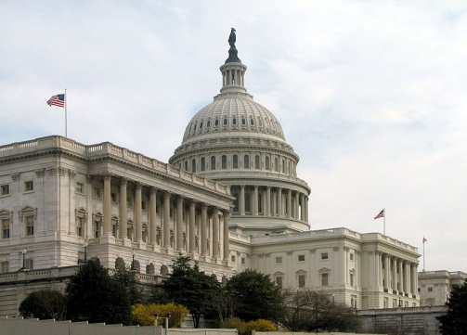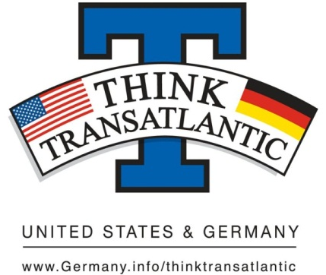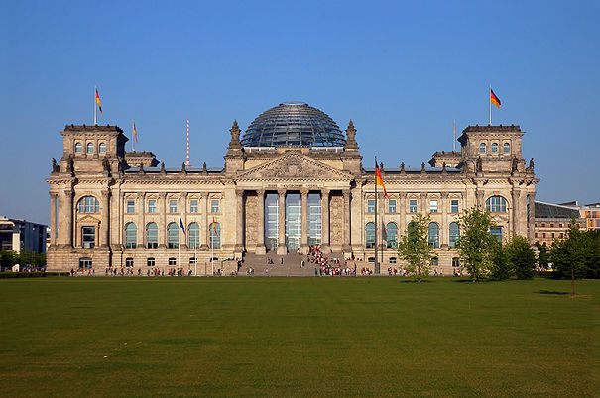

Think Transatlantic Campus Week
The Embassy of the Federal Republic of Germany has selected Washington and Jefferson College as one of 25 universities nationwide to participate in this year’s October 2012 Campus Week, with the theme "Think Transatlantic--The US and Germany in the 21st Century."

Think Transatlantic Essay Contest
Think Transatlantic – The United States and Germany

Possible Essay Topics:
1) Assess the future relevance of the U.S.- German partnership against the backdrop of our globalized world order.

2) Evaluate the significance of the Marshall Plan for transatlantic relations, both back in 1948 and today.

3) Is NATO mostly obsolete or more important than ever? What should its political and military role be?

4) The Cold war-- Discuss America’s impact on European integration.

5) Will transatlantic relations suffer or be reinforced by a rising China -- Assess.

6) Robert Kagan’s ‘Paradise of Power’-- America Mars, Europe Venus. Describe the significance of transatlantic relations with particular regard to common values.

7) Describe the evolution of the transatlantic relationship between Germany and the United States. Where will it lead to in the future?

8) Immigration and integration: Discuss differences in the immigration policies between the United States and Germany. What can we learn from each other?

9) Does the transatlantic climate change partnership still matter? Does it need to be strengthened or to be changed after the Copenhagen climate summit and if so, how?

10) Defending democracies under threat: What can and should be a transatlantic response to promoting, consolidating, and sustaining democracy around the world?

W&J 1st, 2nd and 3rd place will receive a gift card for amazon.com ($150, $100, $50 respectively). The best essay will be entered into the national completion. National Winners will be published in a renowned political magazine, featured on www.Germany.info and receive a financial reward.

Submission Deadline: October 5th, 2012, 5pm.
Please send your essay (2500 words max.) to Dr. Judith Atzler – jatzler@washjeff.edu

